Vocational Qualification Assessment Centre (VQAC)

Meeting Your VQ Needs

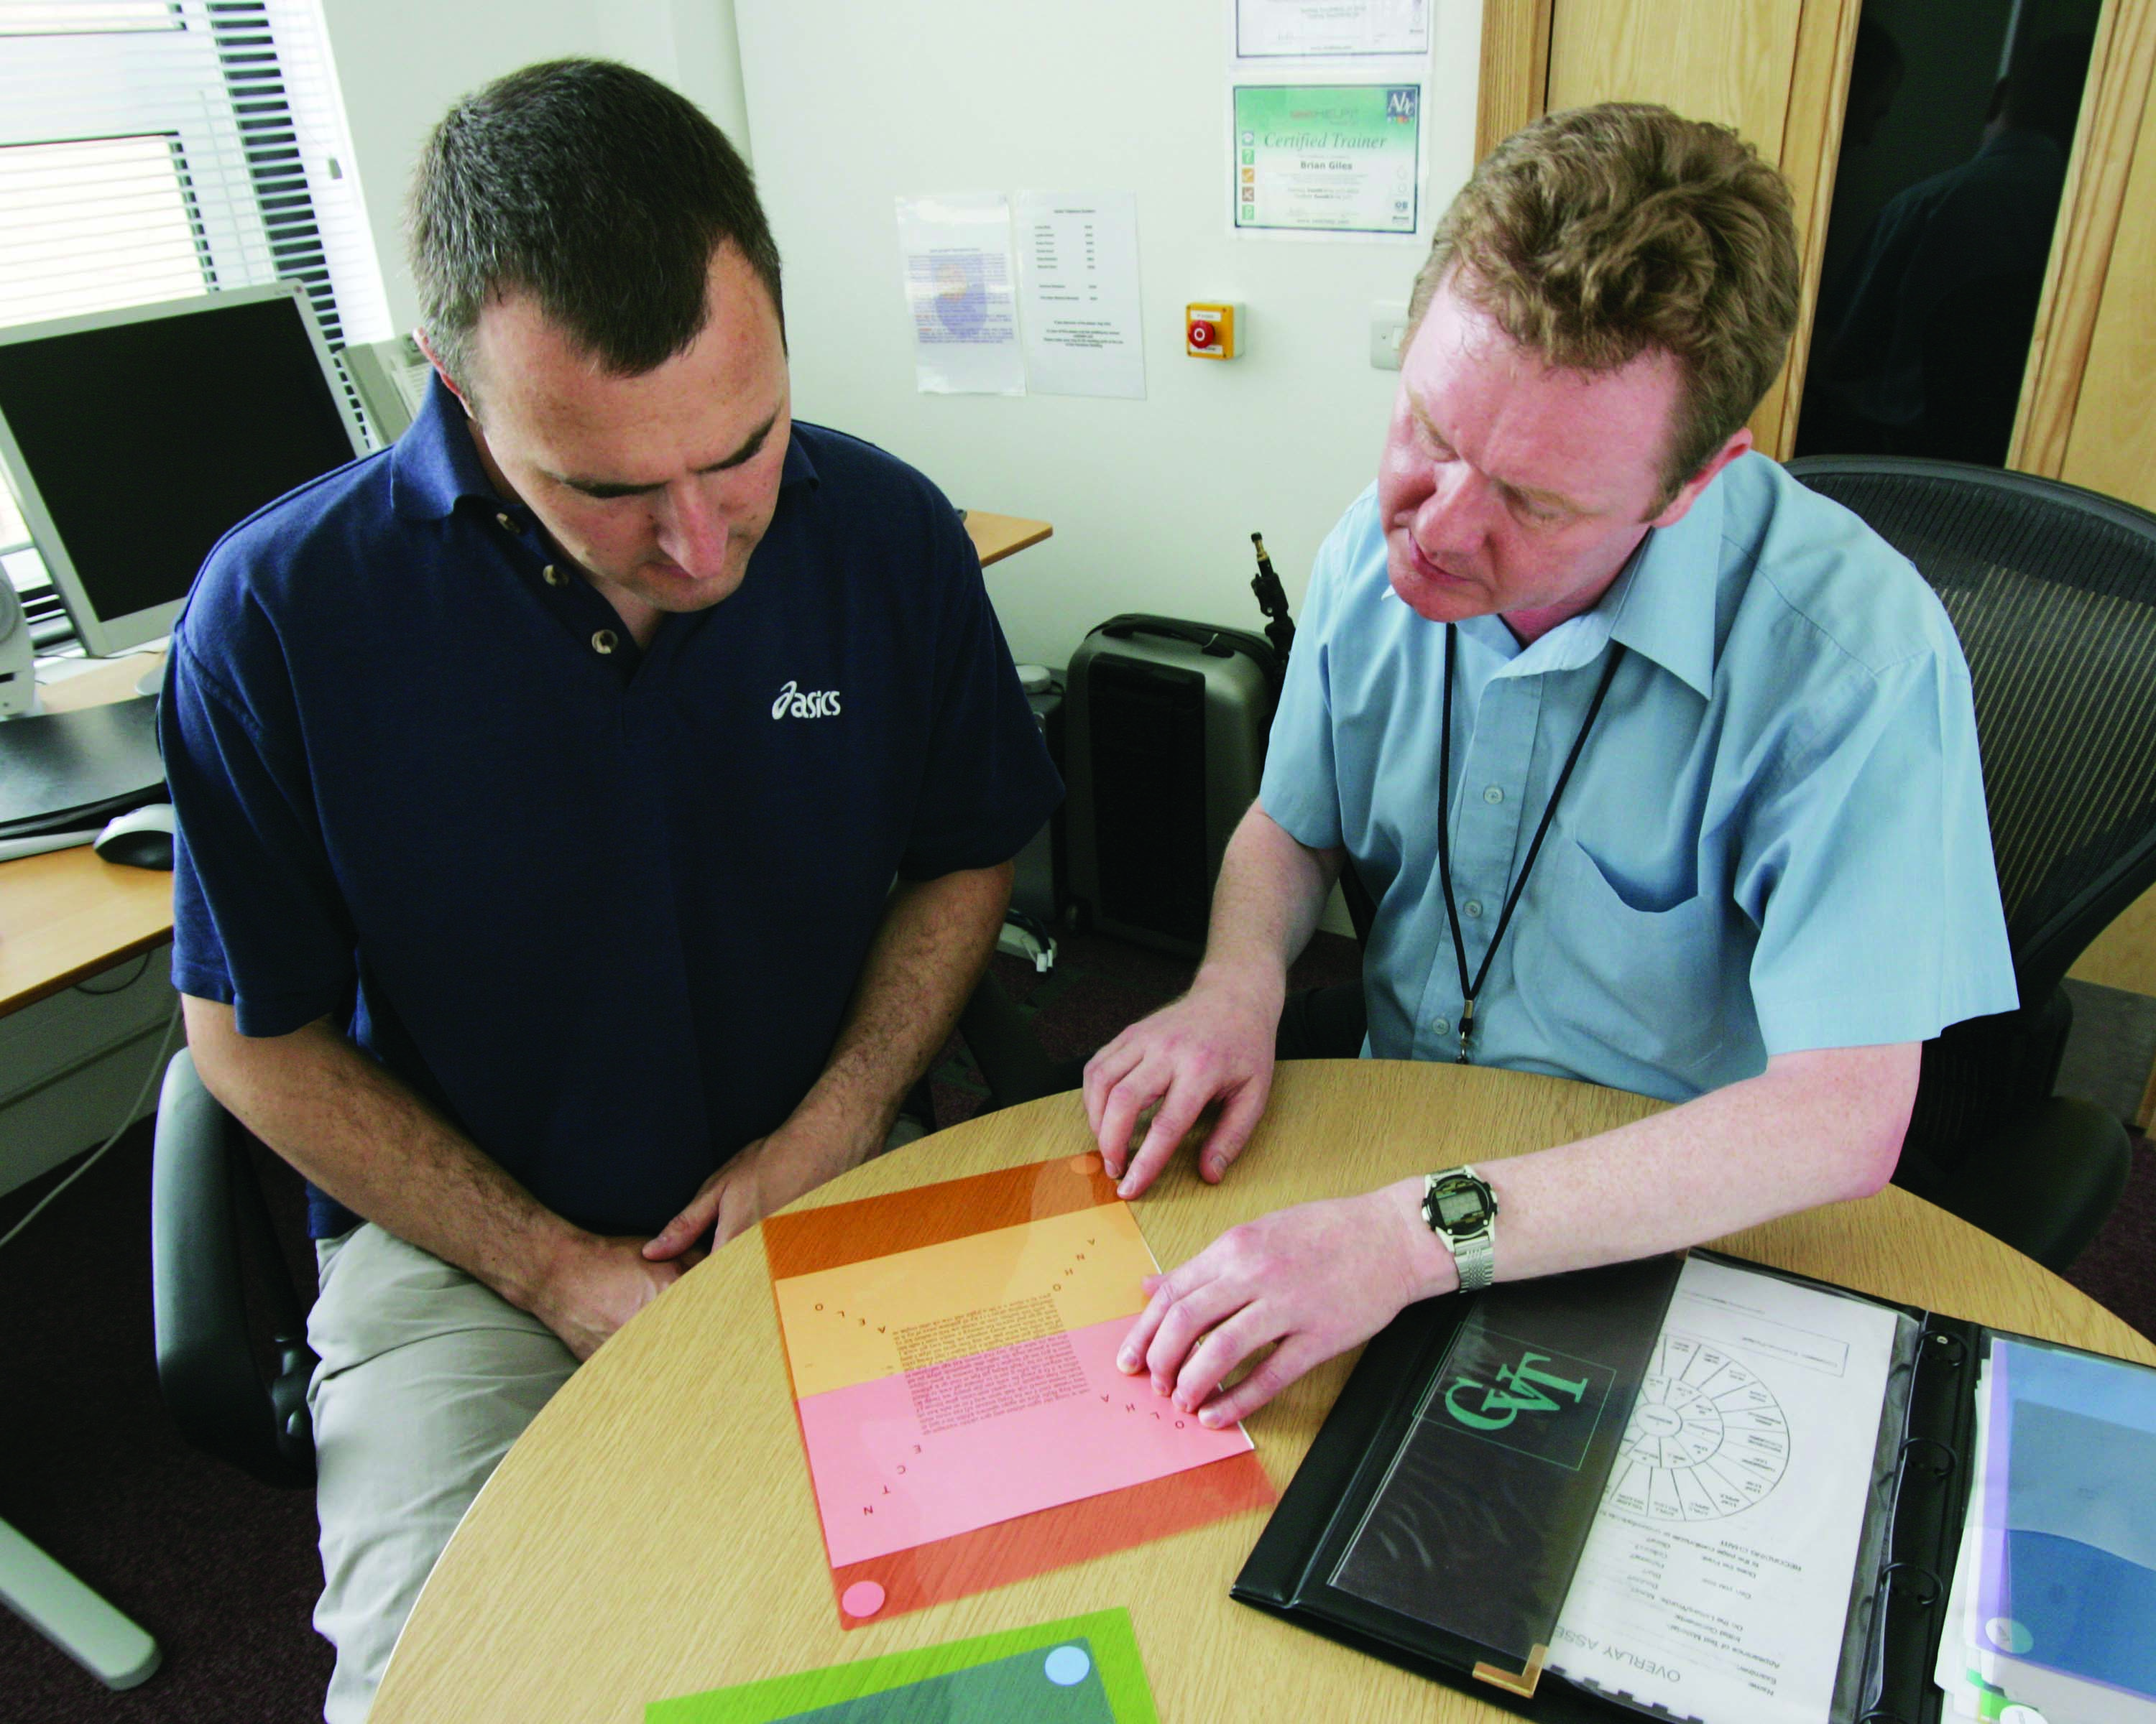

Contents

Section 1 Introduction
Section 2 Completing a qualification with VQAC
Section 3 Eportfolio Accessibility
Section 4 Examples of provision
Section 5 Contacting VQAC
Section 6 Meeting your VQ needs form

Section 1 Introduction

This leaflet summarises the support services and facilities that are available for learners registered with the Vocational Qualification Assessment Centre (VQAC) who have a disability, health condition, mental-health disability or specific learning difficulty (such as dyslexia) that affects their ability to complete their qualification.

The leaflet will tell you about what it’s like to complete a qualification with the VQAC. You will need to think about the facilities you will need to have in place before returning the ‘Meeting your VQ Needs’ form which is included in Section 6. VQAC will then contact you to discuss particular aspects of your requirements.

The University treats any information you give us as confidential. If you have additional requirements and do not let us know, we may not be able to support you effectively. It is also important to let us know if your circumstances change so our records can be updated. You can also complete and re-submit the ‘Meeting your VQ Needs’ form to VQAC at a later date if your circumstances change.

Section 2 Completing a qualification with VQAC

Studying with VQAC may involve:

- Reading material
- Producing written work e.g. case studies or reflective accounts
- Making notes
- Using a personal computer and other information technology to access the internet and qualification websites
- Taking part in face to face discussions with your assessor in your workplace
- Communicating regularly with VQAC and your assessor

Time for learning
You should consider how much time you will be able to put aside at work and at home to gather evidence for your qualification. Your employer may allow you a few hours each week to work towards your qualification. It’s worth asking!

Reading
Most of our materials are in electronic format online and you will be collecting your evidence into an electronic portfolio.

Making notes
This will be an essential part of your qualification as it will allow you to express your understanding and gather evidence of your performance.

Computing
You will need regular and reliable access to the internet and a computer as you will need to spend time working on a computer and most of your work will be assessed online using an electronic portfolio.

Keeping in touch
You can keep in touch with VQAC and your assessor by letter, email and telephone. You can also email your assessor through your eportfolio.

Face to face contact
You will have at least one session of face to face contact with an assessor during the course of your qualification. This will take place in your workplace where your performance will be observed as evidence of your competence.

Section 3 Eportfolio Accessibility

Most of your work will be carried out on an eportfolio system which has the following in-built accessibility facilities:

Font style: All Users can select a preferred font style which will over-ride the centre preferences. Users can choose from a number of styles including Comic Sans which is recognised as a style which can aid reading for users with dyslexia.

Font Size: In addition to browser setting within Internet Explorer, users can select small, medium or large font sizes. All text will then appear as selected; these settings are also applied to the course standards.

Portfolio style: Users can choose a reduced colour option for view portfolio pages. Being able to reduce the colour back-grounds improve the readability of the pages.

Font colour: Users can select a preferred font colour. The colours include black, blue, red, orange and green. Being able to choose a preferred text colour improves readability for users. The site also supports a high contrast setting which will mean the font can be yellow on a black background.

In addition to the above the system also offers users the following features:

Embedded word processor: The eportfolio offers all users the use of an embedded word processor. This means that when accessing the eportfolio users do not need any software other than Internet Explorer 5.1 or later. The word processor can be used in full screen mode allowing the use of a screen reader. The word processor also offers users a spell check facility.

Audio file upload: All sections of the learner portfolio and resource section of the system support audio file attachments. This enables assessors to use audio recordings to provide feedback to learners and agree assessment plans verbally. These audio recordings can then be accessed by the learner accordingly. Enabling the use of audio recordings throughout the assessment process means that learners with additional learning and or support needs can have their evidence recorded in audio format.

Keyboard and mouse controls: The eportfolio is designed for use with or without a mouse. Users can navigate using just the tab and return keys. When using the word processor users can use the Ctrl+ keys to activate functions within the toolbar.

Screen Help: Throughout the eportfolio, users can access page help. The page help contains detailed information for users to explain the actions that can be performed in each screen. We also offer video help which users can download direct to their computer to watch a demonstration of the page.

Section 4 Examples of provision for specific needs

If you are blind or partially sighted
If you’re blind or partially sighted your needs are likely to be mainly related to reading, taking notes and producing written work. We may be able to provide material as Adobe Portable Document Format (PDF) files suitable for a computer with or without assistive technology. PDF files allow you to adjust the text size and background colours. Please note that we can’t guarantee that electronic material will be available in the format you want for your qualification, although we will do our best to meet your wishes.

If you are deaf or hard of hearing
If you’re deaf or hard of hearing your needs will be mainly to do with effective communication between you and your assessor, particularly during observations or when attending support sessions. Please tell us the best way to communicate with you. Most of our communication with learners is by letter and email. Should you wish to contact us or your assessor by telephone, you may wish to investigate using BT’s Text Direct service, where an operator passes on messages between a textphone user and an ordinary phone.

If your mobility is restricted
If your mobility is restricted, your needs will be mainly concerned with access to buildings and rooms. The observation visit will usually be at your normal workplace so shouldn’t cause you any additional problems. Please use the observation planning activity to alert your assessor to any issues that may occur during your workplace observation.

If your manual skills are restricted
If your manual skills are restricted, your requirements will be mainly to do with written work, handling books and using equipment. You will be expected to submit all your work electronically however it is equally acceptable to scan in hand-written work. You’ll need to consider how you will produce clearly hand written work in a reasonable time, perhaps by using a friend or relative as a scribe.

If you have a specific learning difficulty
If you have a specific learning difficulty such as dyslexia, dyspraxia, dyscalculia or attention deficit disorder, your needs will be to do with processing information. Learners with dyslexia could have difficulty with the large amounts of printed or on screen text in our qualifications as most are delivered online. Most electronic text can be manipulated on a computer allowing you to adjust the text size and background colours or with software to convert the text into speech. Handwriting, spelling and getting ideas down on paper in a logical order can also be helped by using computers and appropriate software.

If you have a speech impairment
If you have a condition that affects your speech your requirements will be mainly to do with communication with your assessor and VQAC. At other times you’ll be able to communicate either by letter or email if you want to although we suggest you make it clear how you would prefer to be contacted. All of our assessors can be contacted by email. Before an observation, you might like to consider contacting your assessor to explain what would help you and to give an idea of how you manage in other similar situations. If you have significant difficulty in using the phone, you could consider trying either a textphone or a fax machine. Textphones are widely used by people who are deaf or hard of hearing. If you have access to a fax machine, you can also use this to communicate with VQAC.

Examples of other VQAC provision
This list shows examples of other sorts of provisions that VQAC has available to meet your needs:

- Changing the background and/or font colour of any hardcopy materials that make reading easier
- Changing the font style and size of any hardcopy materials
- Converting documents to PDF files for use with Adobe 5-9 which has an inbuilt screen reader
- Providing vocational qualification standards in Word or PDF depending upon your needs
- Carrying out professional dialogues by phone
- Agreeing to use expert witness testimony
- Using website compatible with Dragon screen reader
- Writing qualification materials which allow learners work progress to be self-directed however we do expect to see regular submissions of work

Section 5 Contacting the Vocational Qualification Assessment Centre (VQAC)

To seek guidance or discuss your specific needs further you can contact us:

In writing: VQ Assessment Centre,
Business Development Unit
Perry Building (East) First Floor
Walton Hall,
Milton Keynes
MK7 6AA

By telephone: +44 (0) 1908 653774

By email: vq-enquiries@open.ac.uk

Section 6 Meeting Your VQ Needs Form

It is important you read the leaflet called ‘Meeting your VQ Needs’ before you fill in this form

Part 1 Your details

I understand that you will treat the information I have provided on this form as confidential, and will pass it on to Open University (OU) staff and the University’s agents as appropriate, for the purpose of providing me with services and facilities as a registered learner with The Open University Vocational Qualification Assessment Centre. I give you permission to process the information for this purpose.

Your signature

Date

Title First name or names Surname or family name

Your contact details OU Personal Identifier

Day

Evening

E-mail

Qualification you are working towards

Qualification Start date

Part 2 Your circumstances

Name of disability, health condition, mental health disability or specific learning difficulty:

Please provide information below to explain to us what we can do to help you to work through your qualification effectively.

We will do our best to provide services to help you learn effectively, but we can’t guarantee that we will be able to provide all the services and facilities you ask for. If we can’t do something you’ve asked for, we will try to suggest a suitable alternative.

Please send your completed form to The Vocational Qualification Assessment Centre, Business Development Unit, Perry Building (East) First Floor, Walton Hall, Milton Keynes MK7 6AA. Alternatively you can send it by email to vq-enquiries@open.ac.uk
Vocational Qualification Assessment Centre Office Use ONLY
(This section must be completed by a member of VQAC’s Learner Support Team)

Date received

Checked by Date

Referred to Date

Profile summary

General and educational implications

Other information

